**IoT Engineer C Test Task report**

* Programming language: C (Embedded)
* IDE: Visual Studio 2022
* Target: ESP32 Dual core WIFI and Bluetooth SoC
* SDK: ESP-IDF 4.4.1
* Hosted on: <https://github.com/aroshani1985/IoT-Engineer-C-Test-Project>

**Summary:**

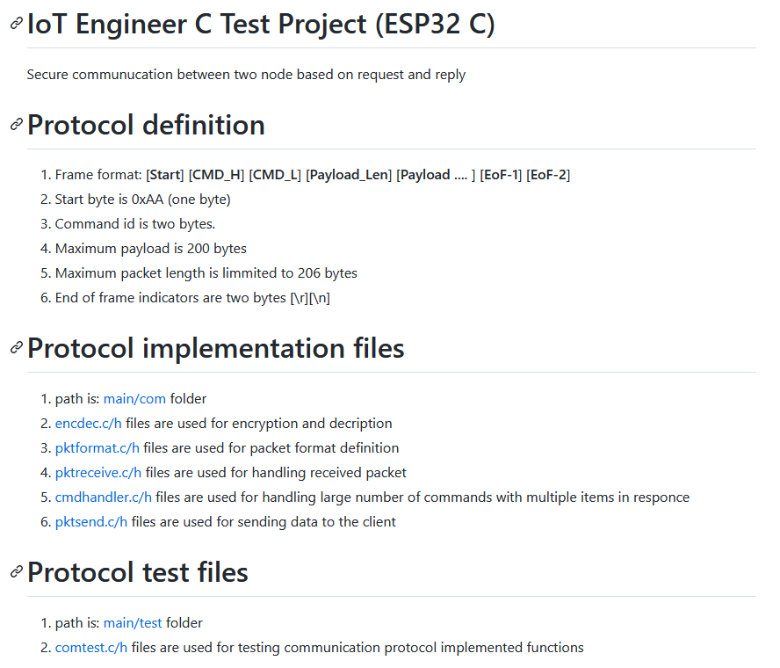

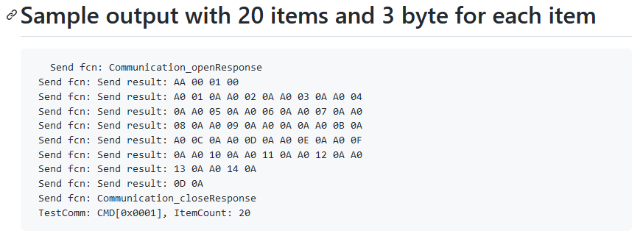

**Project Structure**

1. **Main file**
2. **GPIO just for test the target**
3. **COM for protocol implementation**
4. **TEST for implementing test functions**

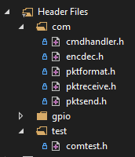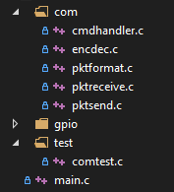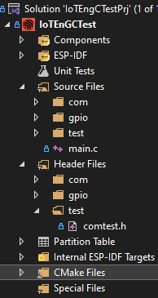

**Main loop:**

1. Run test function
2. Simple blink of MCU

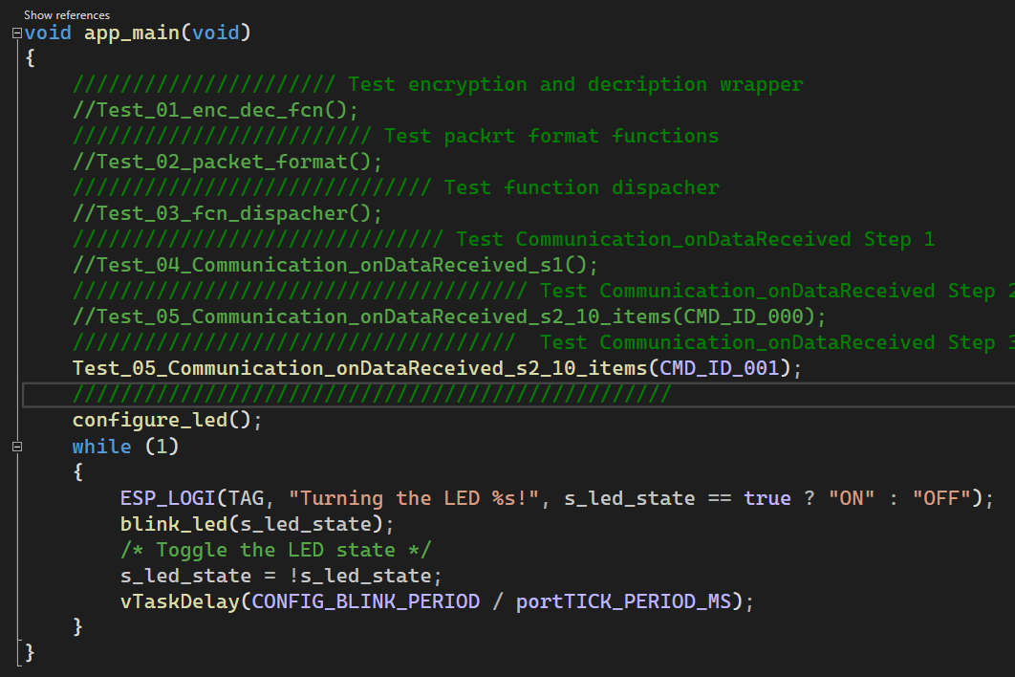

**Test Functions:**

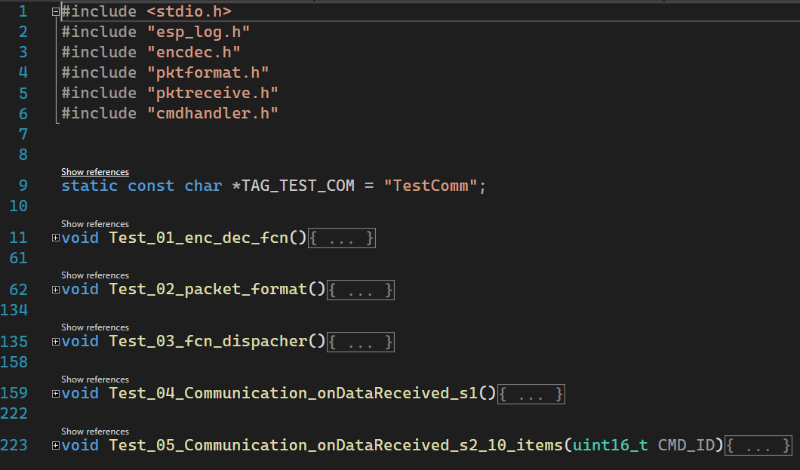

**Protocol Implementation:**

1. **This part is in com folder and contain 5 independent parts.**

* **Encryption and decryption**
* **Packet format definition**
* **Packet receiver**
* **Packet sender**
* **Command handler and response generator**

Encrypt

Decrypt

Packet receiver

Packet

Format

**Command Handler**

Packet sender

**Encryption and decryption functions:**

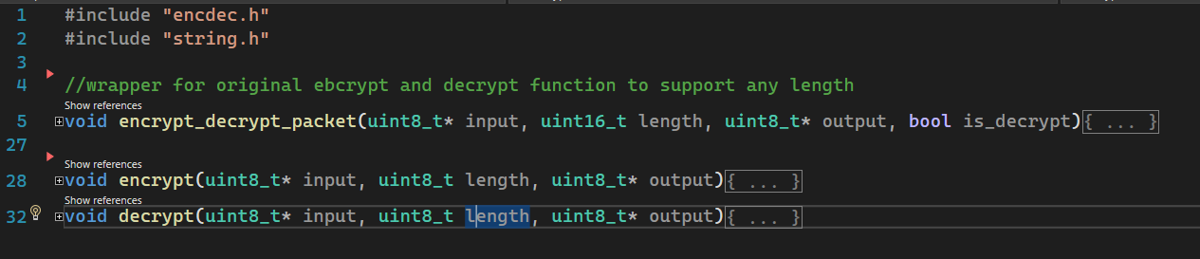

**Packet format functions:**

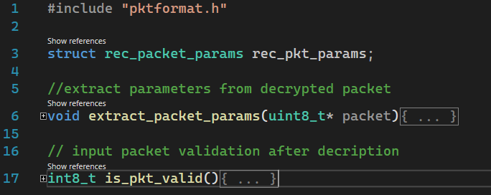

**Packet receiver functions:**

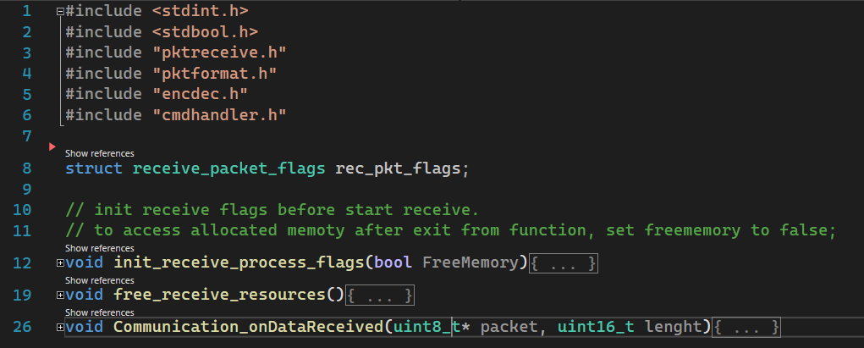

**Packet Sender functions:**

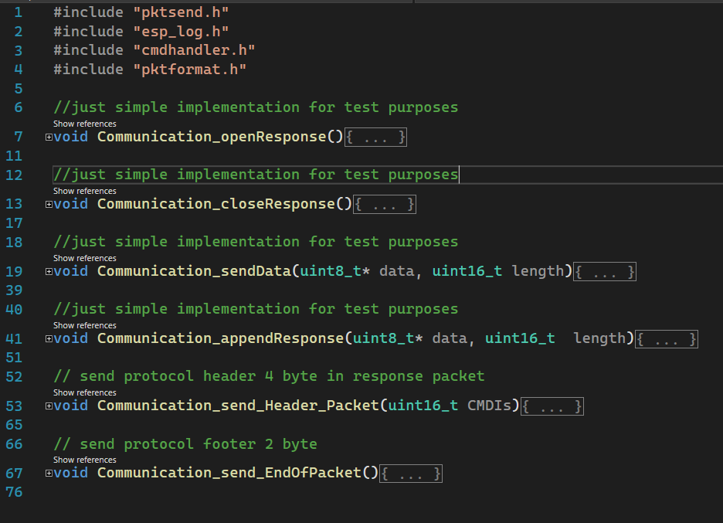

**Command handler functions:**

